SARAH ALBEE BOOK ORDER FORM
On March 11th, Sarah Albee will be visiting West Patent students. Sarah is a New York Times bestselling author of more than 100 books for kids, ranging from preschool through middle grade. Recent nonfiction titles have been Bank Street College of Education Best Books selections, Notable Social Studies Trade Books, and winners of Eureka! Nonfiction Children’s Book Awards. These days she writes primarily nonfiction, and especially loves writing about topics where history and science connect

If you would like to order books autographed to your child or as a gift to someone else, please return this form with payment in a marked envelope to WPESA-Author Visit. Orders are due by FRIDAY, FEBRUARY 14TH. Orders received after the deadline may be late in fulfillment and may have a signed bookplate, rather than a signature in the book.

PLEASE MAKE CHECKS PAYABLE TO: WPESA

TITLE | PRICE | QUANTITY | FIRST NAME(S) (for personalization)
North America: A Fold Out Graphic History (Hardcover) | $20.00
Dog Days of History (Hardcover) | $20.00
POISON: Deadly Deeds, Perilous Professions, and Murderous Medicines (Paperback) | $18.00
George Washington, First President (Paperback) | $5.00
Martin Luther King Jr: A Peaceful Leader (Paperback) | $5.00
Why’d They Wear That? (Hardcover) | $20.00
Bugged! How Insects Changed History (Paperback) | $18.00
Poop Happened (Paperback) | $19.00

STUDENT’S NAME:______________________________

PHONE:_________________________ TEACHER:____________________________

**Please see reverse side for title descriptions**

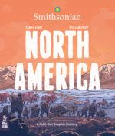
North America: A Fold Out Graphic History
North American history unfolds in this graphic timeline that places the United States, Canadian and Mexican/Caribbean histories in the context of their continent. A richly illustrated, foldout graphic history of the United States, Canada, Mexico, and the islands of the Caribbean.
Dog Days of History
Kids will be swept across world history as they learn the hilarious, fascinating, and complete story of man's best friend, from the first domesticated dogs, to the massive mastiffs that came over with Christopher Columbus on his voyage to the New World, to the pampered pooches of kings and queens, to hero dogs like Sergeant Stubby.

POISON: Deadly Deeds, Perilous Professions, and Murderous Medicines
Science geeks and armchair detectives will soak up this non-lethal, humorous account of the role poisons have played in human history. Perfect for STEM enthusiasts!
George Washington, First President (Beginner Reader K-2)
Beginning readers will learn about the milestones in George Washington’s life in this Level Two I Can Read biography, which combines a traditional, illustrated narrative with historical illustrations at the back of book—complete with a timeline, illustrations, and interesting facts about the United States’ first president.

Martin Luther King Jr: A Peaceful Leader (Beginner Reader K-2)
The life of civil rights activist Dr. Martin Luther King Jr. is introduced in this early reader biography.
Beginning readers will learn about the milestones in Martin Luther King Jr.’s life, which combines a traditional, illustrated narrative with historical photographs at the back of book—complete with a timeline, illustrations, and interesting facts.

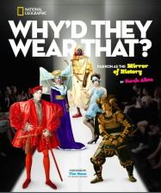
Why’d They Wear That?
Move over Project Runway. Get ready to chuckle your way through centuries of fashion dos and don'ts! In this humorous and approachable narrative, kids will learn about outrageous, politically-perilous, funky, disgusting, regrettable, and life-threatening creations people have worn throughout the course of human history, all the way up to the present day.
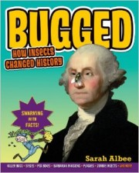
Bugged! How Insects Changed the World
Bugged is not your everyday history book. Insects have had a monumental impact on our history. Bugged is acombination of world history, social history, natural science, epidemiology, public health, conservation, and microbiology told with fun and informative graphics and in an irreverent voice, making this one fun-to-read book.
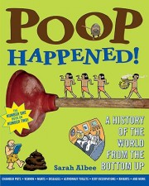
Poop Happened
History finally comes out of the water-closet in this exploration of how people's need to relieve themselves shaped human development from ancient times to the present. Throughout time, the most
successful civilizations were the ones who realized that everyone poops, and they
had better figure out how to get rid of it!

