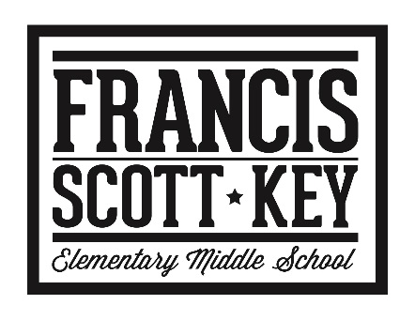





**STUCK FOR A BUCK**

**Victim #2: Ms. DiResta!!**

**Victim #1: Ms. Dircks!!**

February 6, 2019

$1.00 EACH PIECE

Purchase pieces of duct tape to help us stick your favorite teachers to the wall!

All proceeds go to the





Leukemia and Lymphoma Society!

**Victim #4: Ms. Rhea!!**

**Victim #3: Mr. Mutolo!!**