****Girls on the Run is so much fun!

**We inspire girls to be joyful, healthy and confident using a fun, experience-based curriculum which creatively integrates running.**

We believe that every girl can embrace who she is, can define who she wants

to be; can rise to any challenge, can change the world. CAN.



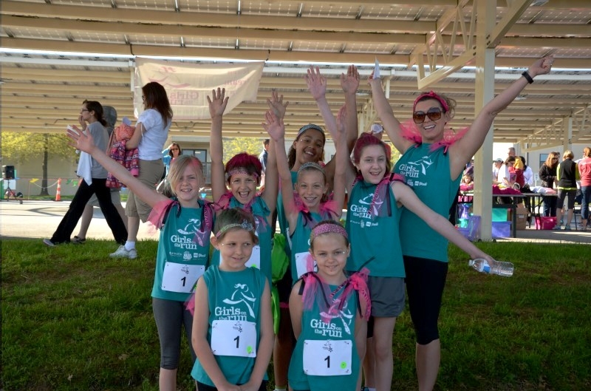



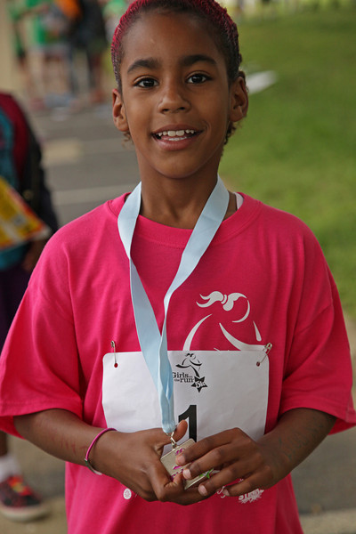



**Season info:**

* Season Starts the week of February 4th
* Teams practice 2x per week for 10 weeks;

-------insert days and times----------

* Teams size is 8-20 participants.
* On-line Registration Opens Monday 01/21 [www.gotrchesapeake.org](http://www.gotrchesapeake.org)
* Lottery to Assign Teams Monday 01/30
* **Season ending celebration 5k is Saturday, April 28 at Druid Hill Park. 9AM Start**

**Please contact: Coach __________________ or ____________if you have any questions.**

**For more information:**

**www.gotrchesapeake.org**

**laura@gotrchesapeake.org**