Hip-Hop class@ Francis Scott Key
Mondays, 3:10-4:10pm (8 Weeks, beginning October 8th)
4-6th Graders, $79.00/Scholarships Available!!

Info Session on Friday, October 5th at 3:00pm for students and/or Parents (meet in lobby of FSK)

Register Now:
https://docs.google.com/forms/d/1mC8GAAe6bhbsTY6DRubEIRgREV4sK37onV7Qod7L2ug/viewform?edit_requested=true

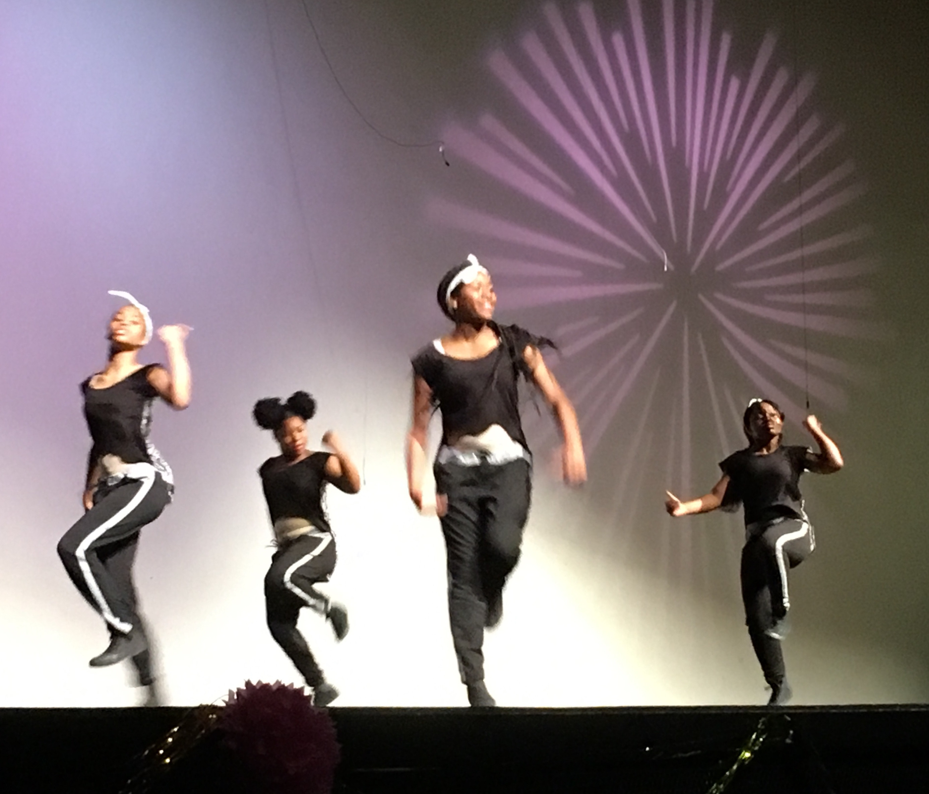
www.dancehappensinc.com
dancehappensincasp@gmail.com
410-929-2432 (please contact about a scholarship)

