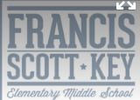

In this 8-session course, you will learn about the development of social-emotional competence in children and acquire 5 key skills that will foster stronger relationships, solve problems, and help structure encouragement and consequences in effective ways.

The Path to Raising Emotionally Resilient Children

RSVP to latudakinkel@icloud.com

Francis Scott Key Elementary/Middle

1425 East Fort Avenue 21230

Thursdays 6:30-8:30pm

October 11th-December 13th

*Skip October 18th & November 22nd*

***“The Mariposa training was hands-down the most transformational experience of my teaching career." - Assistant Principal & parent***

# Mariposa Child Success Programs